**Candoco Dance Company and Jo Bannon**

**Feeling Thing**

**Candoco Dance Company are excited to present Feeling Thing, a dance film project by Jo Bannon.**

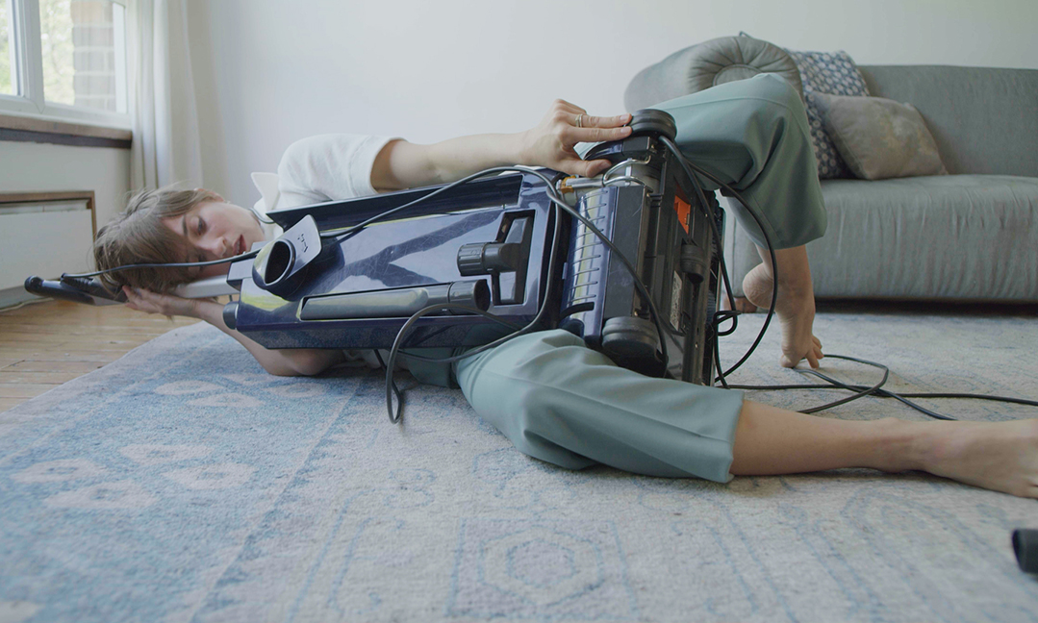

“a provocative, intelligent and at times heartbreaking film”

Fjord Review

Running Time 18 minutes

Age recommendation 12+

Access Audio Description

Closed Captions

Candoco Dance Company invite you to retrain your sensitivity to the liveliness of everyday objects in their latest film Feeling Thing by multi-disciplinary artist and choreographer Jo Bannon.

Matter is lively. If you play the right frequency to your kitchen table, it will explode. You may not have noticed, but your iron has a certain swagger as it glides over polyester. Those of us with the lived experience of disability may already know something of this potential intimacy, this strange kinship, as we dance the daily duet between our bodies and the people, objects and technologies that support us.

In Feeling Thing, the camera captures three intimate duets between object and performer. The ASMR sound encourages you to listen closely and sense the life in them, inviting you to lean into feeling as a sensory, illogical, uncanny space where all things are alive.

Next time you’re in your kitchen, listen more closely to your fridge and pay attention to the shifting moods of the cooker flame. Are we allowed to feel this way about things…these non human things? If we could embrace a radical interdependence of all things, how would we change how we live together? Perhaps we would do less harm. At the very least we would reintroduce ourselves to things around us and experience them as the dancing, feeling things they are.

Feeling Thing is funded by Candoco Dance Company and Arts Council England

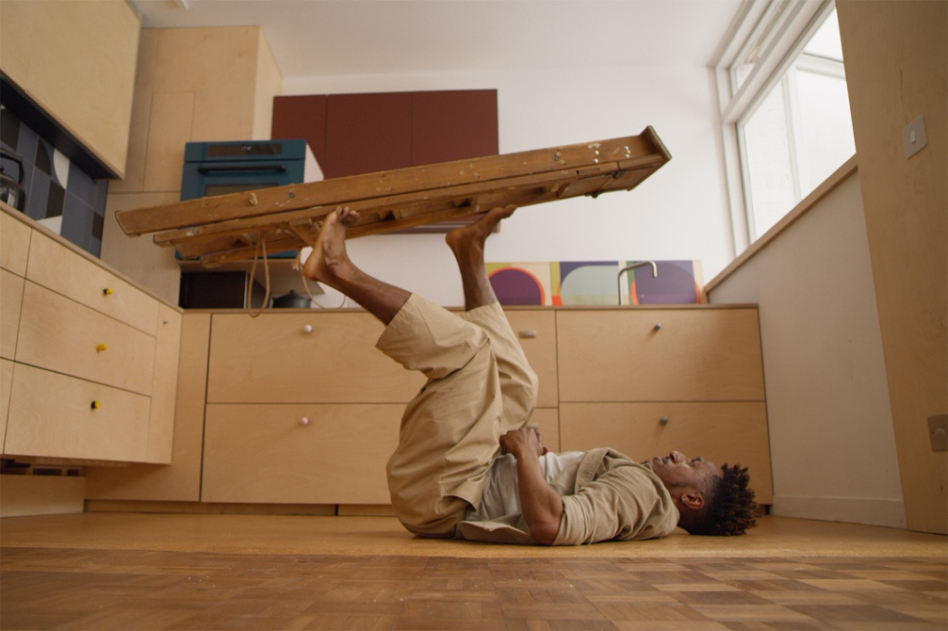

A Candoco Dance Company and Jo Bannon Co-Production

Dancers Anna Seymour

Ihsaan DeBanya

Olivia Edginton

Director and Choreographer Jo Bannon

Co Director, Camera and Editor John Stephenson

Assistant director Charlotte Darbyshire

Producer Ellie Douglas Allen

Assistant producer Georgia Kersh

Director of Photography and Colourist Jack Offord

1st assistant camera Bethany Fitter

Sound Designer Julie Rose Bower

Sound Recordist and Mixer Rob Hart

Production Manager and Gaffer Phil Webb

Best Boy Gravity Randall

Access Consultancy Quiplash

Audio Description Dot Alma

Closed Captions Julie Rose Bower and John Stephenson

Special Thanks to Jules and Mani Maxwell, Philipa and Matthew Stephenson, Cinewest, Rebecca Pierce, Mike Stoner, Harri McKenzie-Donavan, Laura Goulden and Sandy Deo.

Funded by Candoco Dance Company and Arts Council England

You can watch the full length film here:

<insert Vimeo link and password>

Or a trailer

<https://youtu.be/xkCVdayT0Uk>

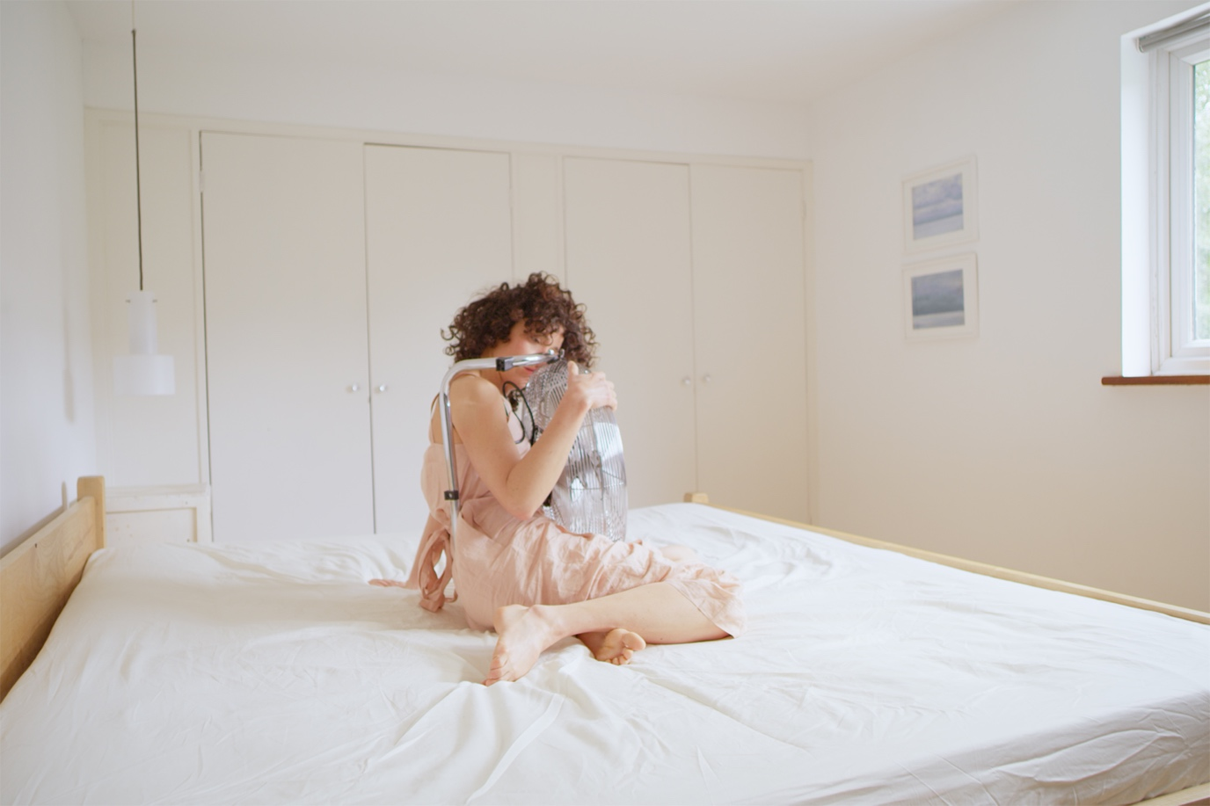

**BIOGRAPHIES**

**Candoco Dance Company**

Celebrating its 30th anniversary, Candoco is a world-leading professional dance company that bridges the mainstream and the experimental. Its bold approach and powerful collaborations create distinctive performances and far-reaching learning experiences for people in the UK and beyond. Candoco celebrates different ways of seeing, of being and of making art, and is at the forefront of conversation around dance and disability and continually expanding perceptions of #whatdancecanbe

**Jo Bannon**

Jo Bannon is a UK based artist working in performance, choreography and live art. Her work is concerned with identity, sensory perception, and human encounter and explores how our physical bodies experience the world around us and how this sensory experience can or cannot be conveyed. Her work is informed by her identity as a disabled woman with albinism and attempts to unpick the ways we look, hear and sense our immediate environment in order to rethink or make unfamiliar these intrinsic human behaviours. Bannons work is led by form and so manifests in various mediums including intimate encounters designed for single or small audiences, staged performance, dance, film and installation.

Jo has presented work in the UK, Europe, South America, USA, China, South Korea and Australia including HAU Berlin, The Barbican, IBT Festival, Art Gallery of Western Australia, Itau Cultural Sao Paulo, The Times Museum Guangzhou and the National Theatre. Jo also works as a dramaturg, educator and writer and is a founder member of artist collective Residence.

Recent work includes Kitchen Alba (2021), Absent Tense (2020), We Are Fucked (2018), Alba (2015), Dead Line (2013) and Exposure (2011).