

Technical Rider

**UK Touring – 2019/20**

|  |
| --- |
| **‘Face In’** Choreographed by Yasmeen Godder |

Running Time: 30 mins

**‘Hot Mess’**

Choreographed by Theo Clinkard

Running Time: 35 mins

**TABLE OF CONTENTS**

PERSONNEL - 3 -

Touring Company - 3 -

First Aid Staff - 3 -

Crew Call - 3 -

Temperature - 4 -

VENUE PROVISIONS - 4 -

Get-In - 4 -

The Stage - 5 -

Dance Floor - 5 -

Mops, Buckets and Hot Water - 5 -

Access - 5 -

Masking - 6 -

**Face In** - 6 -

Scaffolding and Conduit - 7 -

Lighting - 8 -

Lighting Control - 9 -

OSC - 9 -

Sound - 9 -

Sound Control - 9 -

Headset Communication - 9 -

SET - 10 -

‘Face In’ - 10 -

AUDITORIUM - 11 -

Front of House and Clearance - 11 -

RISK ASSESSMENTS AND METHOD STATEMENTS - 11 -

CONTRAS AND CHARGES - 11 -

OTHER - 11 -

APPENDIX 1. - 12 -

Contact Sheet - 12 -

APPENDIX 2. - 13 -

‘Face In’ set image - 13 -

APPENDIX 3. - 14 -

Promoters Check List - 14 -

# PERSONNEL

## 

## Touring Company

Candoco tours with a company consisting of:

1 x Production Manager

1 x Production Electrician

1 x Artistic Director

1 x Rehearsal Director\Company Manager

4 x Female Performers

3 x Male Performers

## First Aid Staff

The promoter will be responsible for ensuring there is adequate First Aid cover.

Candoco have at least one qualified First Aider as part of their Touring Company.

## Crew Call

The Crew Call will greatly depend on the schedule and the theatres requirements. Please contact the Production Manager of Candoco to discuss the crewing requirements for the:

* Get-In / Build
* Rehearsals
* Show
* Re-set
* Get-Out / Strike

The show requires Lighting Crew, Sound Crew, Fly Crew and Stage hands for all calls.

The Get-Out would normally commence straight after the last performance. In the event of performing on consecutive days all set will be re-set after the show in preparation for the next day’s show.

**All crewing must be discussed prior to Candoco commencing work on site.**

DRESSING ROOMS

A minimum of 2 large well-lit clean dressing rooms with access to the following in each room:

* **Wheelchair Accessible toilet and shower**
* 2 make up mirrors and 1 full size mirror
* A clothing rail/rack
* An iron and ironing board
* Electric sockets
* Drinking Water
* Towels for the dancers
* Comfortable chairs for 5
* WIFI access

## Temperature

The Stage, Auditorium and Back stage areas must be well heated and a constant temperature of between 18 and 20 deg C.

# VENUE PROVISIONS

## Get-In

A level access is required from the dock door to stage. With the ability to store flight cases during the performance.

## 

## The Stage

The ideal footprint of the shows is 12m wide by 12m depth.

Ideally, we require 2m cross-over upstage of the set, and 2m wing space on both sides. If the venue cannot accommodate these measurements, please inform the Production Manager as soon as possible. Certain parts of the show may be reworked but only if adequate time is given prior to arriving on site.

The stage should be a level black floor and free of holes, screws, nails, staples and other hazards and must be suitable for dance. The performers are wearing socks or bare feet for a large portion of the show and so the stage must be hazard free.

The stage surface must be flat and NOT raked.

Please note that the stage must be completely Wheel-Chair accessible.

## Dance Floor

We tour the following Dance floor:

1x Matt White Dance Floor measuring 10m Wide by 10m Deep.

If you have one we can use then please let me know beforehand.

Candoco require exclusive use of the performance space from the start of the get-in until the end of the get-out.

## Mops, Buckets and Hot Water

Due to part of the set being white it is very important the theatre is kept as clean as possible. Regular sweeping and mopping of the space will be required and so access to cleaning equipment and hot water will be required on a regular basis. The Candoco Production Manager and Production Electrician are happy to do this cleaning work and you do not need a specific cleaning team.

## Access

A tallescope or ladder (3 Part 14 rung Zarges or equivalent to comfortably and safely reach to 8m rig height) will be required for the Lighting Focus and Set Rigging.

The venue must inform the Candoco Production Manager of any in house policies regarding working at height prior to commencing work.

**Please note:**   
  
**It is NOT possible to do a “Bounce Lighting Focus”**

## Masking

## **Face In**

This performance requires the following in house black masking to be supplied as minimum:

|  |  |
| --- | --- |
| 2m x 7m Black Leg | 1.5m x 10m Black Border |
| 4 | 6 |

All other masking must be able to me moved or de-rigged. If this is not possible e.g. Acoustic Paneling etc. this must be brought to the attention of the Candoco Production Manager.

Candoco Supply the following masking:

|  |  |  |  |  |
| --- | --- | --- | --- | --- |
| 0.4m x 7.5m Black Border | 0.4m x 12m Black Border | 7.5m x 6.5m White German Masking | 12m x 6.5m White Masking | 7m x 2m Black Leg |
| 2 | 1 | 2 | 1 | 2 |

**Hot Mess**

This ideally will be performed with a completely open space without any masking. If the wings of the theatre are untidy we will require full black masking. Please contact the Production Manager to talk through the requirements. Please see the image below.

## Scaffolding and Conduit

**FACE IN**

The Performance Requires the following metal tubing as minimum:

|  |  |  |
| --- | --- | --- |
| Aluminium Scaffolding  48mm x 8m Length | Clean Metal Conduit  13m Length | Clean Metal Conduit  8m Length |
| 2 | 1 | 2 |

## Lighting

The Performance Requires the Following in house Generic Lighting Equipment:

|  |  |  |
| --- | --- | --- |
| Type | | Total |
| FRESNELS | |  |
| 1Kw | | 28 |
| 2Kw | | 7 |
| PROFILES | |  |
| 575W/750w 36° | | 16 |
| 575W/750w 50° | | 12 |
| 575W/750w 15-30° Zoom | | 8 |
| 575W/750w 25-50° Zoom | | 6 |
| PAR CANS PAR 64 | |  |
| 1Kw CP62 | | 8 |
| FLOODS | |  |
| 1Kw Asymmetrical | | 4 |
|  |

Please advise Candoco’s Production Manager not less than three weeks prior to our visit of any shortfall from the above tables.

Please contact the Candoco Production Manager before hiring any equipment as we may be able to adapt and modify the shows design in order to save the theatre financially.

Although ideally each Lighting Fixture would have individual power in some circumstances a certain amount of Floor and Over Head Units can be Paired onto the same power/dimmer if the venue is providing 2.5Kw Dimmers.

All lanterns should have, where applicable; colour frame, shutters, Iris and barn doors.

Lanterns must have clean lenses, shutters and barn doors free from damage. Profiles must have free and full range of zoom and focus.

A detailed Lighting Plan will be sent separately to this rider, this will be a venue specific drawing where a plan view DWG is available. If a plan view DWG is not available a generic Lighting Plan will be sent showing the lighting requirements for the show.

Candoco Dance Company tour all colour required for the performance however we may require additional colour for very large lantern sizes.

Ideally a Pre-rig of lighting fixtures overhead would be arranged. Where a Pre-rig is not available please inform the Production Manager so this can be factored into the Production Schedule and Crew Call.

## Lighting Control

Candoco tour an ETC Nomad Lighting Desk. This desk can control lighting via 2 Universes (1024 Channels) if your theatre setup requires more than 2 Universes please bring this to the attention of the Candoco Production Manager.

If the venue owns an ETC ION, GIO or EOS the Production Manager may want to use your in-house desk instead.

Lighting and Sound will need to be operated from a central position in the auditorium.

## OSC

The lighting desk and the QLAB system will need to talk to each other via OSC. This requires us to connect directly to the desk via cat5. The Sound and Lighting Desks will ideally be situated in the auditorium, however if this is not possible we require a cat5 link between FOH Sound position and lighting operating position. We tour a reasonable amount of cat5 cable, but if there are no tie points and the run is very long please let us know in advance. If connecting to a house network we will of course adjust our device IP addresses to match your network requirements and avoid any IP address clashes.

## Sound

Front of House: Full range system capable of high-quality music reproduction without distortion, hiss or static noise, able to produce an acceptable level of comfortable listening for the audience and equal coverage in every seat of the auditorium, incorporating fills and delays if necessary. It’s essential that there is on-stage monitoring for the dancers.

## 

## Sound Control

Candoco tour a Mac operating QLab and a soundcard with 4 x Outputs.

## Headset Communication

Headset communication between lighting, sound and the stage is essential throughout the performance.

# SET

Candoco tour all Set and Rigging needed for the Performance.

## ‘Face In’

‘Face In’ requires a White Box Space (toured by Candoco). The installation of the white box will make use of 4 x In-house fly bars. The method for the install will be discussed before the work commences. This work will be led by the Candoco Production Manager and Candoco Production Electrician.

All rigging equipment used for this install will be supplied by Candoco. The equipment used meets all European BGVC-1 (German) regulations.

The following combination of Rigging equipment will be used:

* 5mm Custom made steel cables (SWL 300Kg)
* Crosby Bow Shackles (SWL 1 tone)
* Doughty Half Coupler with Eye (SWL 340Kg)
* Reutlinger Type 50SV II with Rings (SWL 330Kg)

Please see **APPENDIX 2** for a drawing/photo of the stage.

Hot Mess

Hot Mess has a number of flown items. A separate plan will be sent with where possible a hanging plot.

All rigging equipment will be supplied by Candoco.

The following combination of rigging equipment will be used:

* Lyon Sewn Sling Lyon 25mm x 30cm (SWL 30KN)
* Lyon Sewn Sling 25mm x 50cm (SWL 30KN)
* Bow Shackle Black Green Pin Marked AVGP6 EN 13889. (SWL 330KG)
* Barton Single/Double Swivel Pulleys (SWL 370KG)

Please see **APPENDIX 2** for a photo/ground plan of the set.

# AUDITORIUM

## Front of House and Clearance

It is very important that the venues Front of House Manager and Candoco’s Production Manager have discussed the appropriate systems prior to the first performance for:

* Opening the House to Audience members
* Giving Clearance
* Late Comers Policy (Audience Members and Staff who are late for the Start of the show)
* Show Stop Procedure
* Post Show Talks / Question and Answer

# RISK ASSESSMENTS AND METHOD STATEMENTS

If required please contact the Candoco Production Manager for a copy of the latest Risk Assessments and Method Statements with regards to this performance.

If you require further information or need Candoco to adhere to any specific Local / Theatre rules or regulations please inform the Production Manager three weeks prior to us working in your theatre.

# CONTRAS AND CHARGES

Any foreseen contras or charges must be discussed with the Candoco Production Manager before arriving on site.

# OTHER

In order to help your venue plan for the arrival of Candoco Dance Company in your venue please see **APPENDIX 3** for the Promotors Check List. This document states all that you as a venue should supply and also lists all the equipment Candoco Dance Company will provide.

Please do not hesitate to contact the Candoco Production Manager if you have any concerns, thoughts or questions with regards to this Technical Rider and Double Bill.

# APPENDIX 1.

## Contact Sheet

Please feel free to use the below contact information should you have any questions or require further information.

**Phil Webb**

Production Manager

[phil@candoco.co.uk](mailto:phil@candoco.co.uk)

02077046845

07891989399

**Ellie Douglas-Allan**

Senior Producer

[ellie@candoco.co.uk](mailto:ellie@candoco.co.uk)

02077046845

**Georgia Kersh**  
Producer

[Georgia@candoco.co.uk](mailto:Georgia@candoco.co.uk)

02077046845

# **APPENDIX 2.**

## ‘Face In’ set image

|  |
| --- |
|  |
| **The above picture shows the set of ‘Face In’ from the Audience** |
|  |
| **This model shows a side view with Legs / Masking and use of Fly Bars** |

Hot Mess Set Image and ground plan

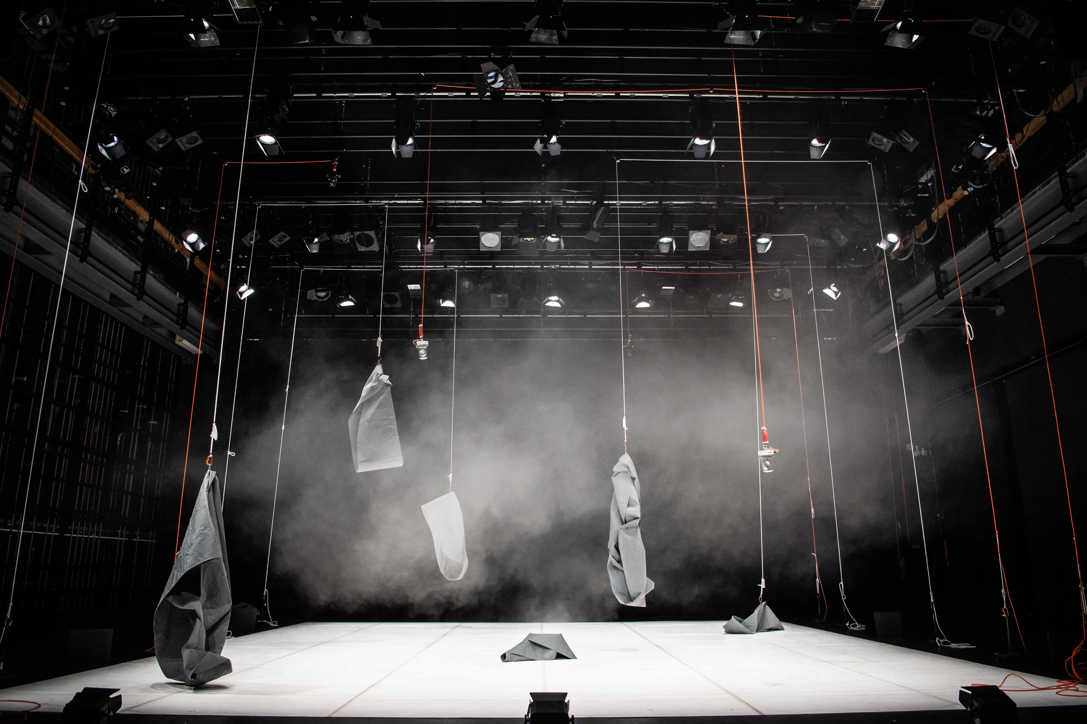



# **APPENDIX 3.**

## Promoters Check List

|  |  |  |  |
| --- | --- | --- | --- |
| Equipment/Service | Amount | Sourced By | Who Supplies |
| **EVENT PLANNING AND ORGANISATION** | | | |
| All planning and documentation specific to the event | | Promoter & Candoco | Promoter & Candoco |
| Scaled CAD drawing of site | | Promoter | Promoter |
| Set Delivery and Pick-up | | Candoco | Promoter |
| Show Risk Assessments and Method Statements | | Candoco | Candoco |
| Venue Specific Risk Assessments and Method Statements | | Promotor | Promotor |
| **THEATRE SERVICES AND INFRASTRUCTURE** | | | |
| Clothing Rails | 2 | Promoter | Promoter |
| Dressing Rooms |  | Promoter | Promoter |
| Drinking Water |  | Promoter | Promoter |
| Emergency Lighting |  | Promoter | Promoter |
| First Aid |  | Promoter | Promoter |
| Full Size Mirrors | 2 | Promoter | Promoter |
| Power |  | Promoter | Promoter |
| Wheelchair Accessible Stage and Backstage |  | Promoter | Promoter |
| Wheelchair Accessible Toilets and Showers |  | Promoter | Promoter |
| Wi-Fi |  | Promoter | Promoter |
| **STAGING** | | | |
| 0.4m x 12m Black Border | 1 | Candoco | Candoco |
| 0.4m x 7.5m Black Border | 2 | Candoco | Candoco |
| 1.5m x 10m Black Border | 6 | Promoter | Promoter |
| 12m x 6.5m White Masking | 1 | Candoco | Candoco |
| 13m length of Clean Metal Conduit | 1 | Promoter | Promoter |
| 2m x 7m Black Legs | 4 | Promoter | Promoter |
| 7.5m length of Clean Metal Conduit | 2 | Promoter | Promoter |
| 7.5m x 6.5m White German Masking | 2 | Candoco | Candoco |
| 8m Length of Aluminium Scaffolding 48mm | 2 | Promoter | Promoter |
| 8m length of Clean Metal Conduit | 2 | Promoter | Promoter |
| 8m Lengths of Aluminium Scaffolding 48mm | 2 | Promoter | Promoter |
| Brooms | 2 | Promoter | Promoter |
| Dustpan and Brush | 1 | Promoter | Promoter |
| Headset Communication | 4 | Promoter | Promoter |
| Hot Water for Mopping |  | Promoter | Promoter |
| Mops and Mop Buckets | 2 | Promoter | Promoter |
| PVC White or Grey Dance Floor Tape |  | Promoter | Promoter |
| White or Grey Harlequin Dance Floor | 10m x 10m | Candoco/Promoter | Candoco/Promoter |
| **ACCESS** | | | |
| Suitable Access with a comfortable and safe working height of 8m from stage | | Promoter | Promoter |
| **LIGHTING EQUIPMENT** | | | |
| 15-30° Profiles | 8 | Promoter | Promoter |
| 25-50° Profiles | 7 | Promoter | Promoter |
| 1Kw Fresnels | 38 | Promoter | Promoter |
| 2Kw Fresnels | 8 | Promoter | Promoter |
| 36° Profiles | 16 | Promoter | Promoter |
| 50° Profiles | 12 | Promoter | Promoter |
| Asymmetrical Floods | 10 | Promoter | Promoter |
| Par Can with CP62 Lamps | 8 | Promoter | Promoter |
| LED Floor Floods | 7 | Candoco | Candoco |
| Hanging Fuzz Lights | 5 | Candoco | Candoco |
| Boom Arms | 24 | Promoter | Promoter |
| Booms | 8 | Promoter | Promoter |
| Control of Working Lights and House Lights |  | Promoter | Promoter |
| Dimmers |  | Promoter | Promoter |
| ETC (1024) Nomad Lighting Desk and Computer |  | Candoco | Candoco |
| Gel / Colour |  | Candoco | Candoco |
| **AUDIO EQUIPMENT** | | | |
| 13amp 4 way at FOH/Control position | 2 | Promoter | Promoter |
| 13amp power sockets at FOH/Control position. | 2 | Promoter | Promoter |
| Adequate PA and Subs |  | Promoter | Promoter |
| Mac Book Pro with QLab Professional | 1 | Candoco | Candoco |
| Mixing Desk | 1 | Promoter | Promoter |
| Onstage Monitors providing fold back on stage | 4 | Promoter | Promoter |
| Red Male XLR to RCA Phono | 4 | Candoco | Candoco |
| Scarlett 2i4 Soundcard | 1 | Candoco | Candoco |
| Sennheiser SM58 Radio Microphone  (For Post Show Talk if Applicable) | 2 | Promoter | Promoter |
| Sufficient audio cabling for all other Audio Equipment |  | Promoter | Promoter |
| **LOCALCREW/STAFF** | | | |
| Crew call including Lighting, Sound, Fly and Stage Crew (Quantity to Be Decided) | | Promotor | Promoter |